Why should I leave my child at the door of his room??
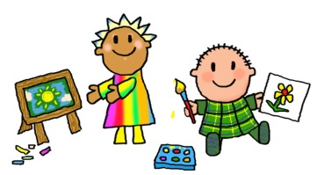
Leaving your child at the door helps him to know that you recognize the teacher’s ability to properly teach and care for him. Your consistency in departing and returning promptly helps him to develop a healthy sense of trust. In addition, waiting outside the door:
- Enables teachers to focus on interacting with the preschoolers, rather than becoming involved with adult conversation;
- Makes the transition from parent-to-room and room-to-parent smoother for the child;
- Prevents the anxiety some preschoolers may feel if they see parents leaving with children and wonder if their parents will return for them;
- Helps maintain a clean, safe play space for preschoolers who are “floor people”; and
- Prevents small fingers and toes from being stepped on during floor play.
Because we sincerely care about your special preschooler, we offer this suggestion for assuring his safety and happiness. It’s best for parents not to linger in the classroom, especially at the beginning of the school year. We do encourage you to visit when you can and eat lunch with us. Thanks for your cooperation with this request. We are looking forward to a terrific year!

